- SCENARIO A: Basic Mixed workload

-CURRENT PROCESS LIST
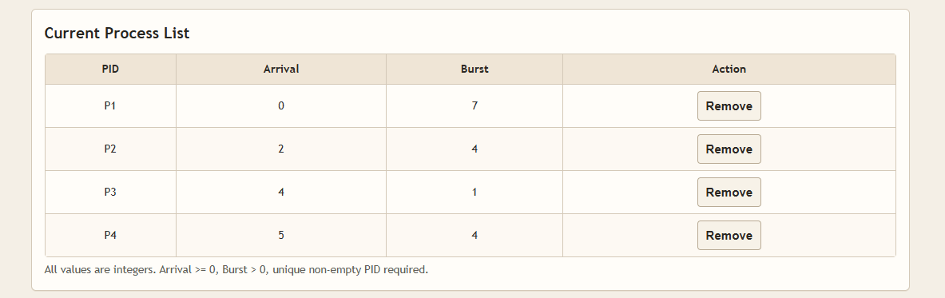

-Round robin (queue view , gantt chart and result[including AT, BT ,CT, WT, TAT,
RT ,AVG WT,AVG TAT and AVG RT])
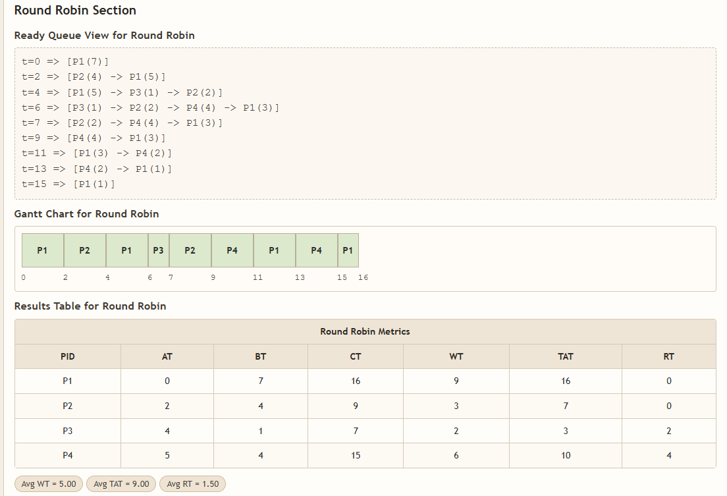

-STRF (gantt chart and result[including AT, BT ,CT, WT, TAT, RT ,
AVG WT,AVG TAT and AVG RT])

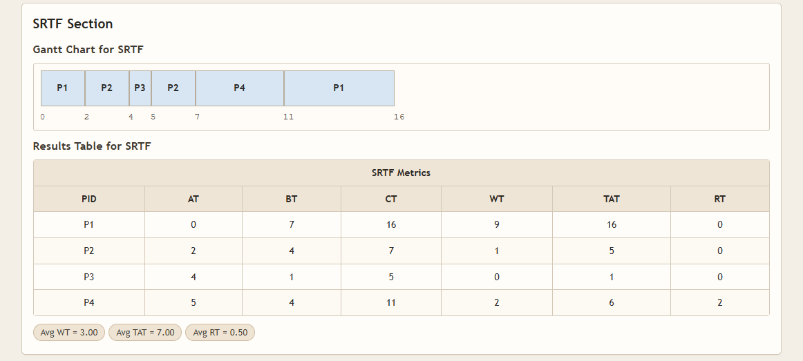

-ANALYSIS
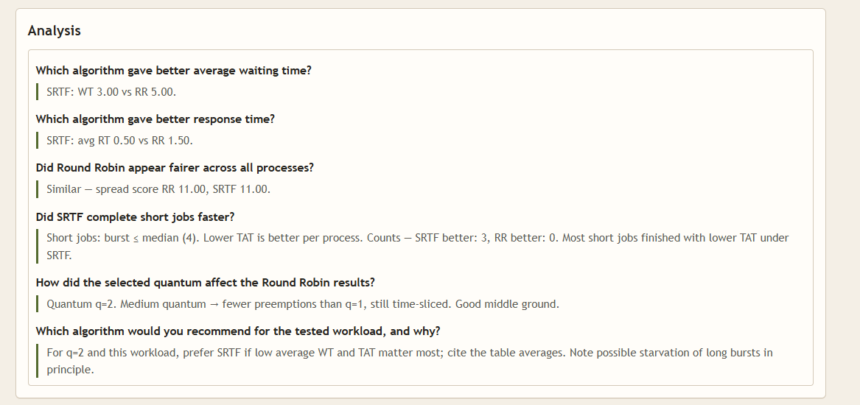
-CONCLUSION
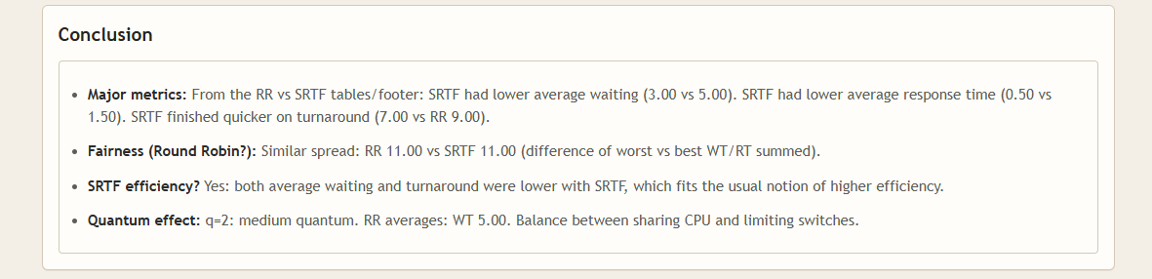

- SCENARIO B: QUANTUM SENSTIVITY CASE

-CURRENT PROCESS LIST
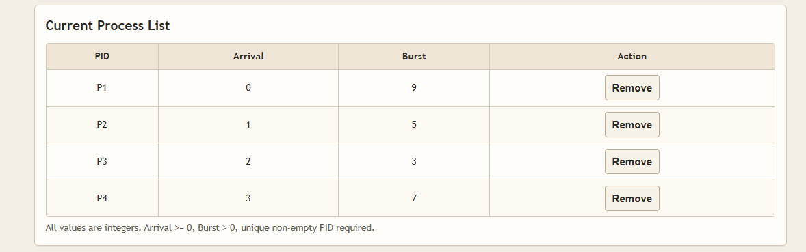

-ROUND ROBIN (QUEUE VIEW)
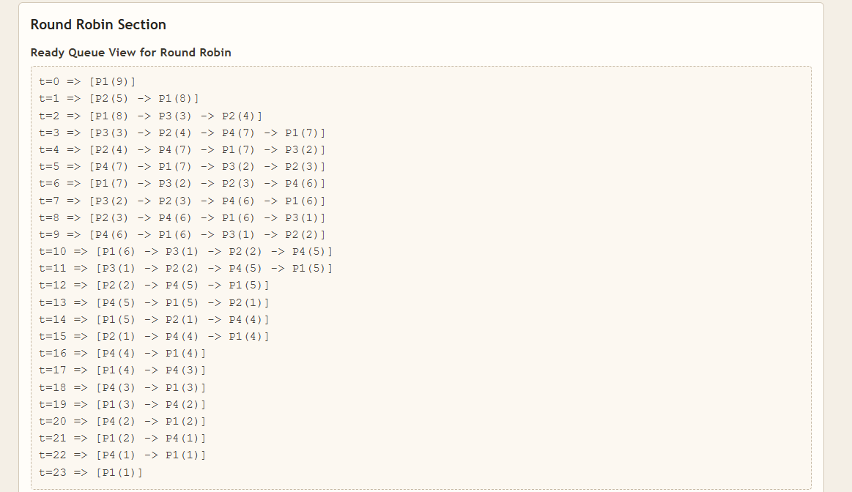

Round robin (gantt chart and result[including AT, BT ,CT, WT, TAT,
RT ,AVG WT,AVG TAT and AVG RT])

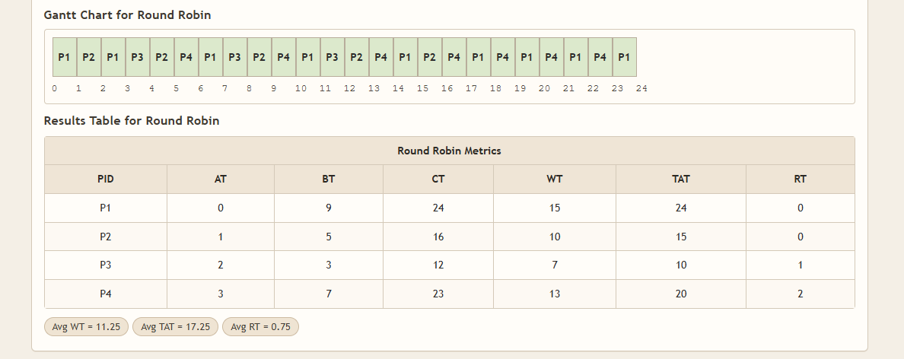

-STRF (gantt chart and result[including AT, BT ,CT, WT, TAT, RT ,
AVG WT,AVG TAT and AVG RT])

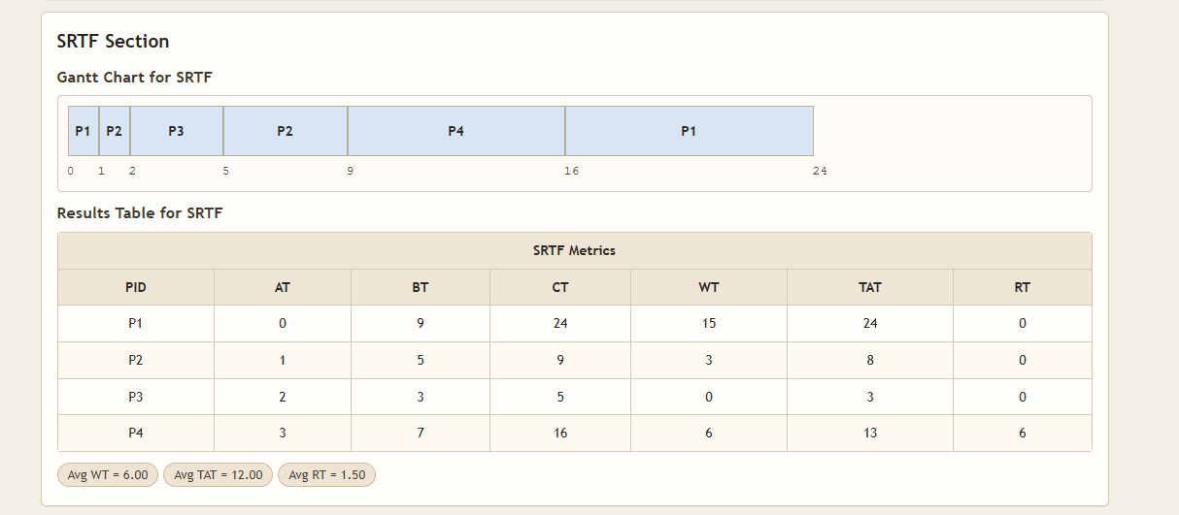

-ANALYSIS

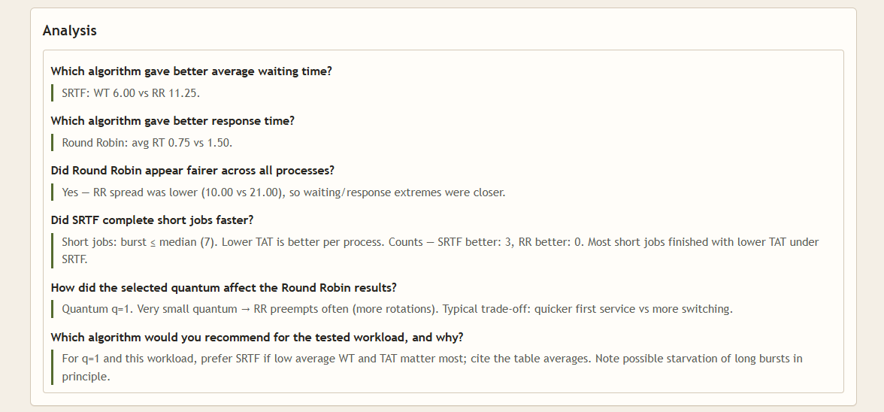

-CONCLUSION
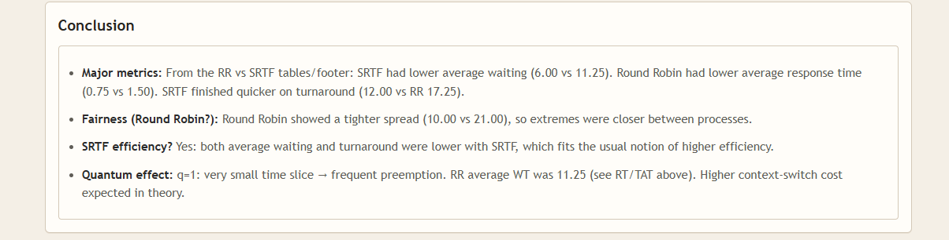

3-SCENARIO C: SHORT-JOB HEAVY CASE

-CURRENT PROCESS LIST

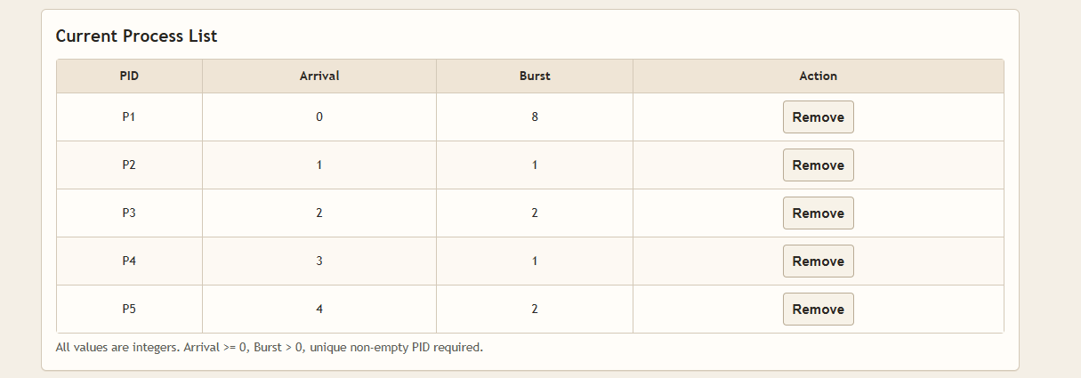

-Round robin (queue view , gantt chart and result[including AT, BT ,CT, WT, TAT,
RT ,AVG WT,AVG TAT and AVG RT])

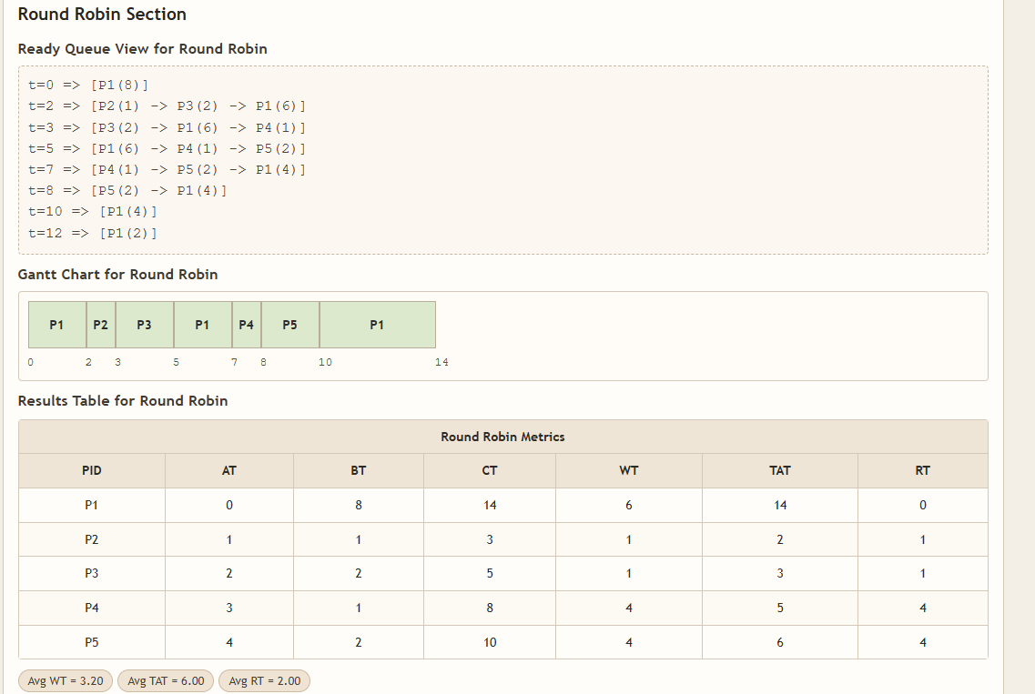

-STRF (gantt chart and result[including AT, BT ,CT, WT, TAT, RT ,
AVG WT,AVG TAT and AVG RT])

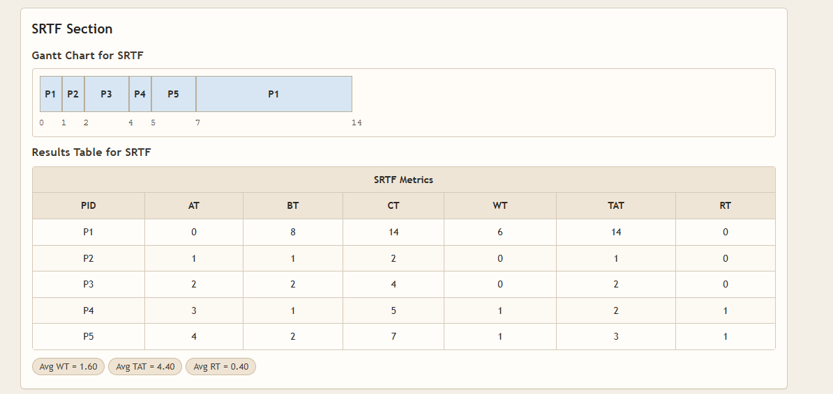
-ANALYSIS
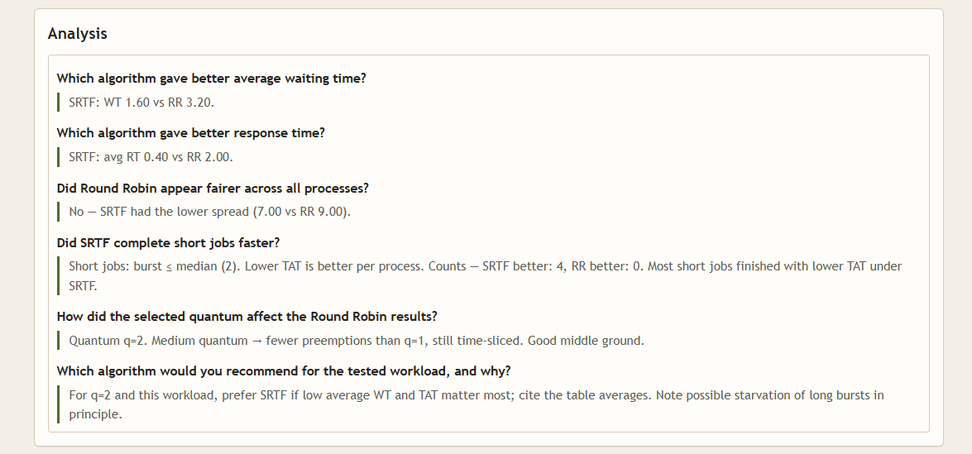

-CONCLUSION
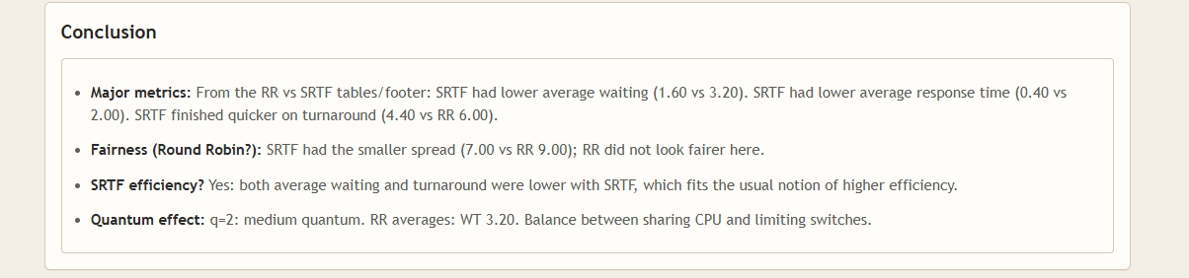

SCENARIO D: INTERACTIVE-STYLE FAIRNESS CASE

-CURRENT PROCESS LIST

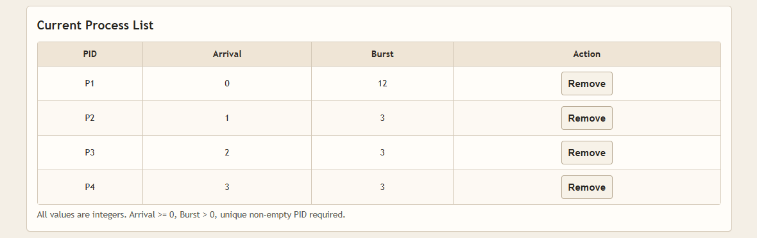

-Round robin (queue view , gantt chart and result[including AT, BT ,CT, WT, TAT,
RT ,AVG WT,AVG TAT and AVG RT])
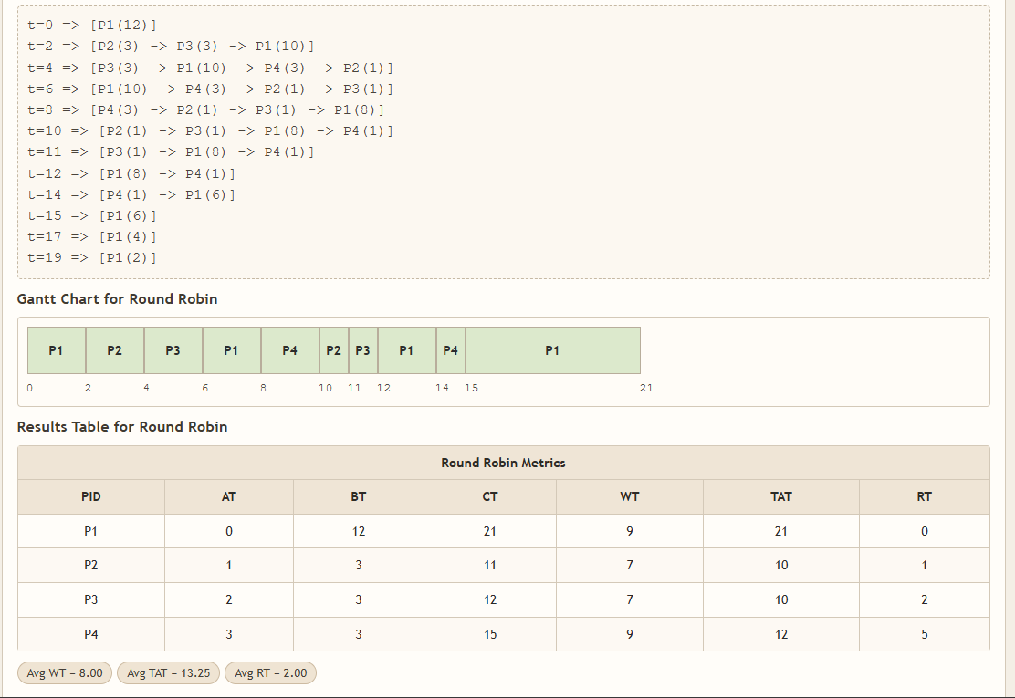

-STRF (gantt chart and result[including AT, BT ,CT, WT, TAT, RT ,
AVG WT,AVG TAT and AVG RT])

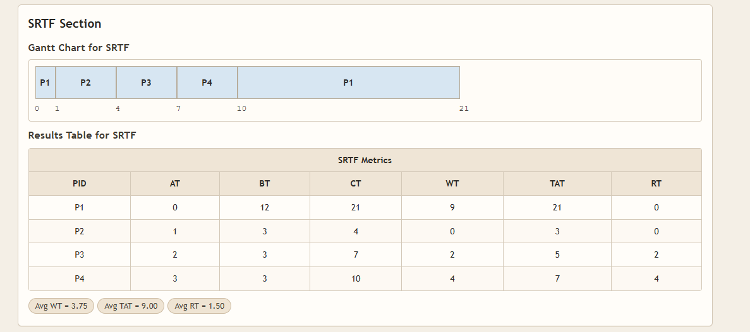

-ANALYSIS

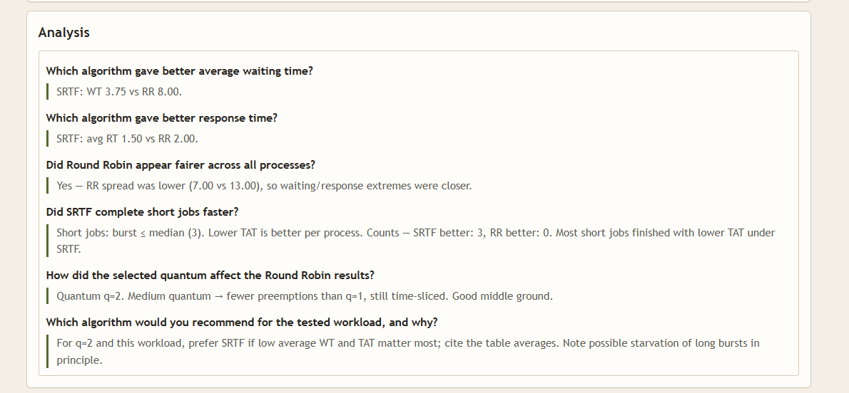

-CONCLUSION
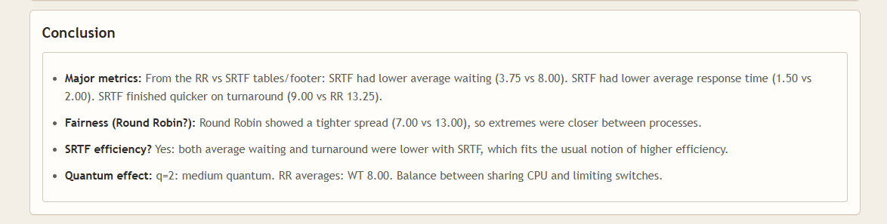

SCENARION E:VALIDATION CASE(INVALID EXAMPLE)
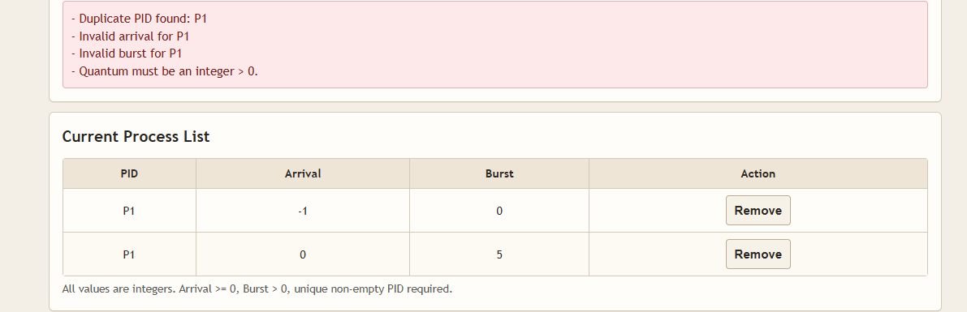

THANKS :)

